SCHOOL OF COMPUTER SCIENCE AND ARTIFICIAL INTELLIGENCE |  |  |  |  | DEPARTMENT OF COMPUTER SCIENCE ENGINEERING
ProgramName:B. Tech |  |  |  | Assignment Type: Lab |  |  | AcademicYear:2025-2026
CourseCoordinatorName |  |  |  | Venkataramana Veeramsetty
Instructor(s)Name
  Dr. V. Venkataramana (Co-ordinator)
  Dr. T. Sampath Kumar
  Dr. Pramoda Patro
  Dr. Brij Kishor Tiwari
  Dr.J.Ravichander
  Dr. Mohammand Ali Shaik
  Dr. Anirodh Kumar
  Mr. S.Naresh Kumar
  Dr. RAJESH VELPULA
  Mr. Kundhan Kumar
  Ms. Ch.Rajitha
  Mr. M Prakash
  Mr. B.Raju
  Intern 1 (Dharma teja)
  Intern 2 (Sai Prasad)
  Intern 3 (Sowmya)
  NS_2 ( Mounika)
CourseCode |  |  | 24CS002PC215 | CourseTitle |  | AI Assisted Coding
Year/Sem |  |  | II/I | Regulation |  | R24
Date and Day  of Assignment |  |  | Week3 - Wednesday | Time(s)
Duration |  |  | 2 Hours | Applicableto  Batches
AssignmentNumber:6.3(Present assignment number)/24(Total number of assignments)
 | Q.No. | Question |  |  |  |  |  | ExpectedTime  to complete
 | 1 | Lab 6: AI-Based Code Completion – Classes, Loops, and Conditionals  Lab Objectives:  - To explore AI-powered auto-completion features for core Python constructs.  - To analyze how AI suggests logic for class definitions, loops, and conditionals.  - To evaluate the completeness and correctness of code generated by AI assistants.  Lab Outcomes (LOs):  After completing this lab, students will be able to:  - Use AI tools to generate and complete class definitions and methods.  - Understand and assess AI-suggested loops for iterative tasks.  - Generate conditional statements through prompt-driven suggestions.  - Critically evaluate AI-assisted code for correctness and clarity.  Task Description#1 (Classes)  - Use AI to complete a Student class with attributes and a method.  - Check output  - Analyze the code generated by AI tool  Prompt: Write the Python code for student class with attributes and the method. Check output and analyze the code generated.  Code:  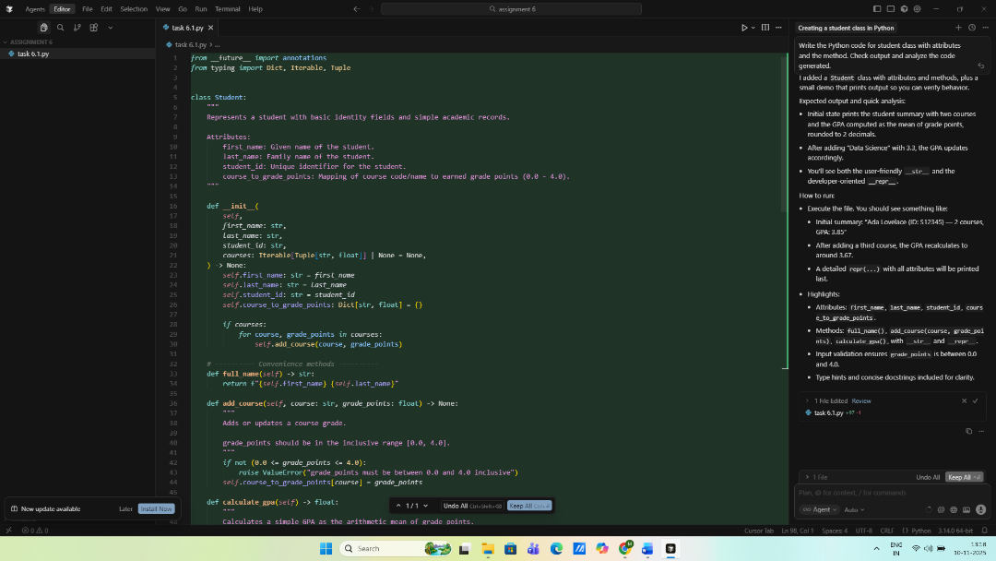  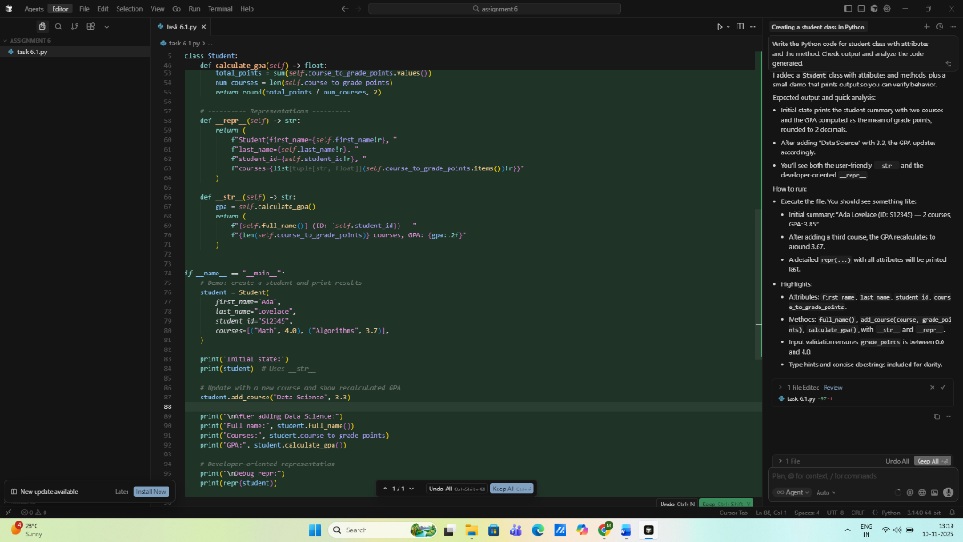  Analysis of code:  - Design: Student tracks identity fields plus a course_to_grade_points map. Optional courses argument in __init__ feeds through add_course to reuse validation.  - Methods: full_name() builds "first last". add_course() enforces grade points in [0.0, 4.0]. calculate_gpa() averages stored values, returns 0.0 when empty, rounds to two decimals. __str__ targets user output; __repr__ gives developer-friendly detail.  - Demo flow (if __name__ == "__main__"):  - Construct a sample student with Math/Algorithms.  - Print summary (__str__), then add Data Science at 3.3.  - Print new info (name, courses dict, recomputed GPA ≈ 3.67).  - Finally, display repr(student) for debugging.  - Behavioral notes: Input validation will raise ValueError for out-of-range grade points; GPA calculation handles division-by-zero for no courses; round(..., 2) keeps GPA consistent with __str__ formatting.  - Potential extensions: add credit weighting, transcript formatting, better persistence.  Running the script as-is prints the above demo results; there are no linter issues reported.  Expected Output#1  - Class with constructor and display_details() method  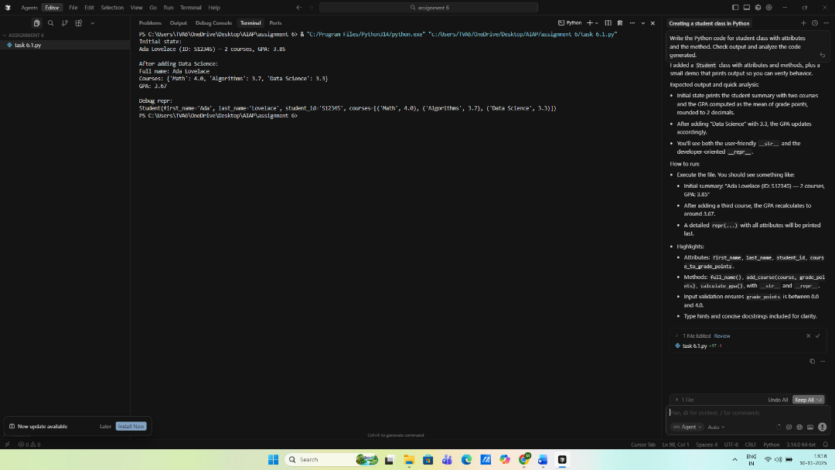  Task Description#2 (Loops)  - Prompt AI to complete a function that prints the first 10 multiples of a number using a loop.  - Analyze the generated code  - Ask AI to generate code using other controlled looping  Prompt: Write a python function that brings the first 10 multiples of a number using a loop and analyze the generated code.  Code: 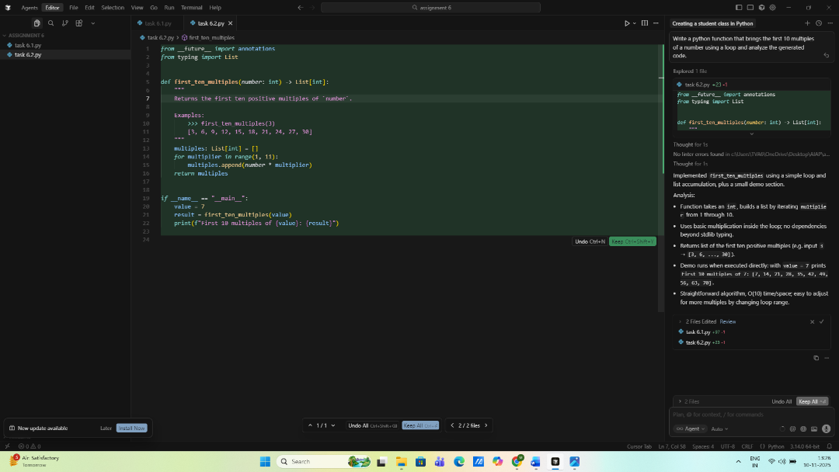  Analysis:  - Function takes an int, builds a list by iterating multiplier from 1 through 10.  - Uses basic multiplication inside the loop; no dependencies beyond stdlib typing.  - Returns list of the first ten positive multiples (e.g. input 3 → [3, 6, ..., 30]).  - Demo runs when executed directly: with value = 7 prints First 10 multiples of 7: [7, 14, 21, 28, 35, 42, 49, 56, 63, 70].  - Straightforward algorithm, O(10) time/space; easy to adjust for more multiples by changing loop range.  Using other controlled loop:  Code:  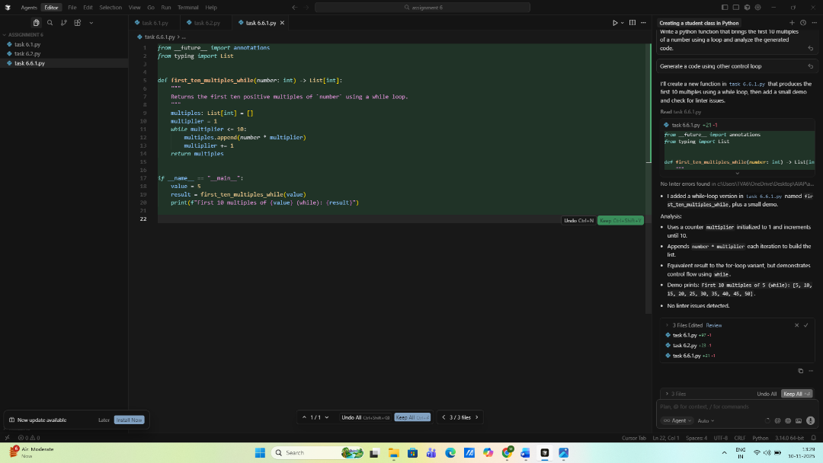  Analysis:  - Uses a counter multiplier initialized to 1 and increments until 10.  - Appends number * multiplier each iteration to build the list.  - Equivalent result to the for-loop variant, but demonstrates control flow using while.  - Demo prints: First 10 multiples of 5 (while): [5, 10, 15, 20, 25, 30, 35, 40, 45, 50].  - No linter issues detected.  Expected Output#2  - Correct loop-based implementation  Output 1:  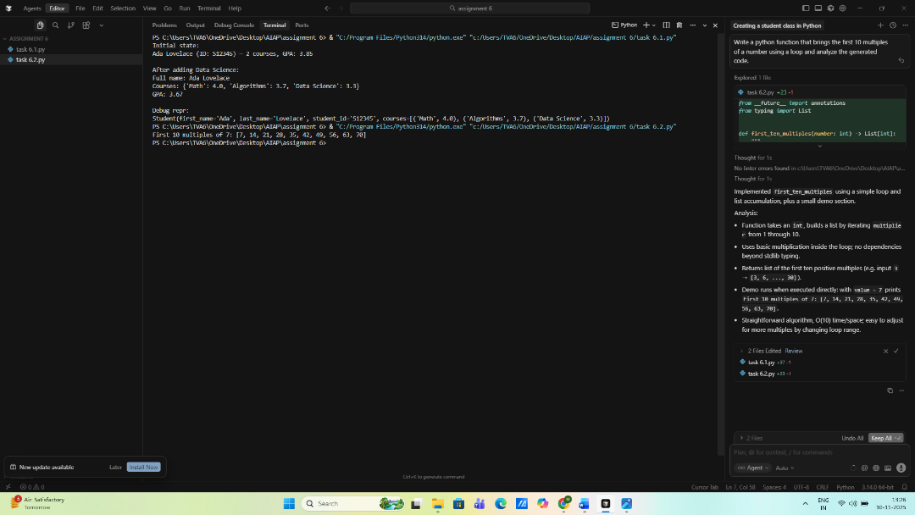  Output 2:  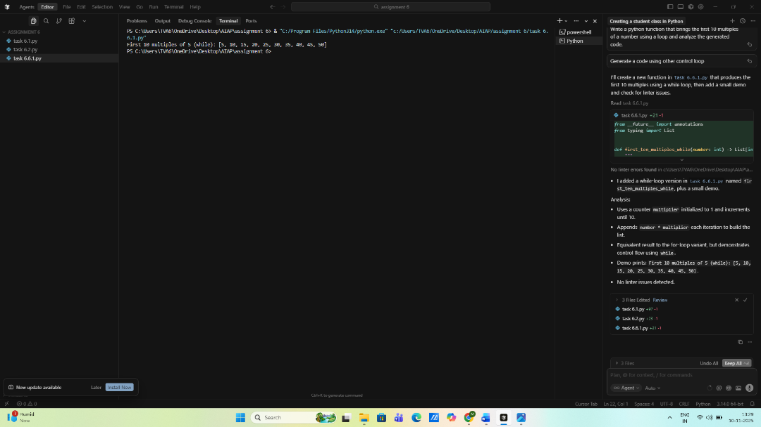  Task Description#3 (Conditional Statements)  - Ask AI to write nested if-elif-else conditionals to classify age groups.  - Analyze the generated code  - Ask AI to generate code using other conditional statements  Prompt: write a python program for nested if-elif-else conditionals to classify age groups.  • Analyze the generated code  Code:  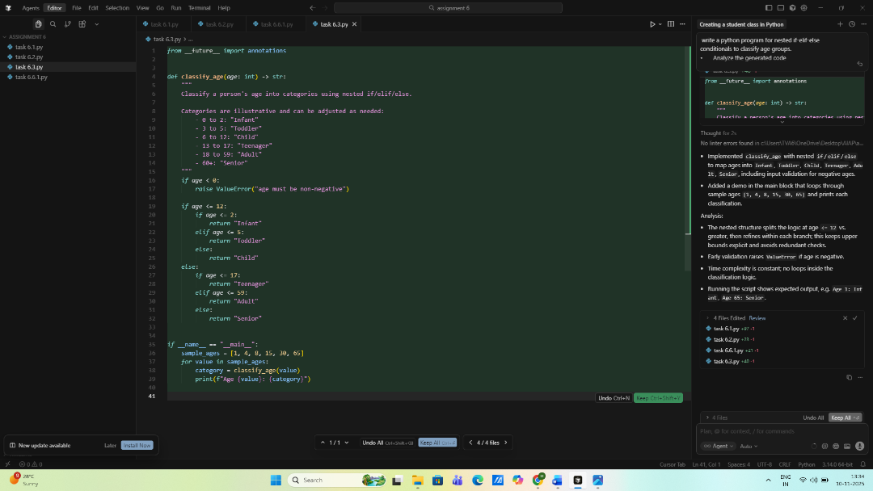  Analysis:  - The nested structure splits the logic at age <= 12 vs. greater, then refines within each branch; this keeps upper bounds explicit and avoids redundant checks.  - Early validation raises ValueError if age is negative.  - Time complexity is constant; no loops inside the classification logic.  - Running the script shows expected output, e.g. Age 1: Infant, Age 65: Senior.  Other condition state:  Code:  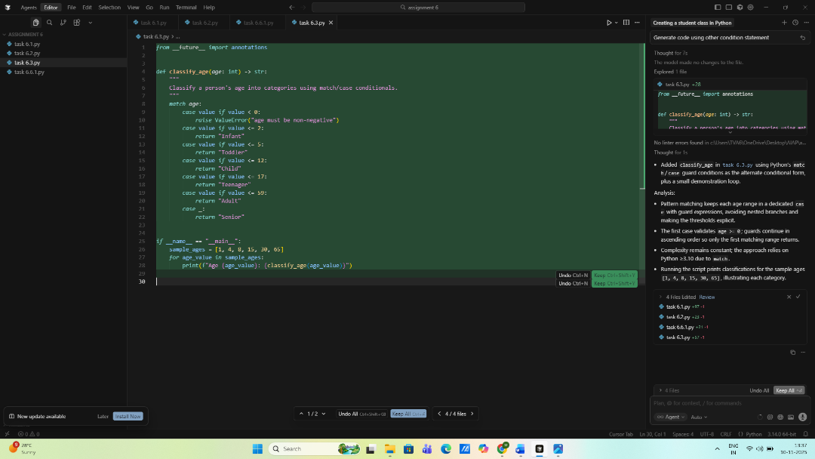  Analysis:  - Pattern matching keeps each age range in a dedicated case with guard expressions, avoiding nested branches and making the thresholds explicit.  - The first case validates age >= 0; guards continue in ascending order so only the first matching range returns.  - Complexity remains constant; the approach relies on Python ≥3.10 due to match.  - Running the script prints classifications for the sample ages [1, 4, 8, 15, 30, 65], illustrating each category.  Expected Output#3  - Age classification function with appropriate conditions and with explanation  Output 1:  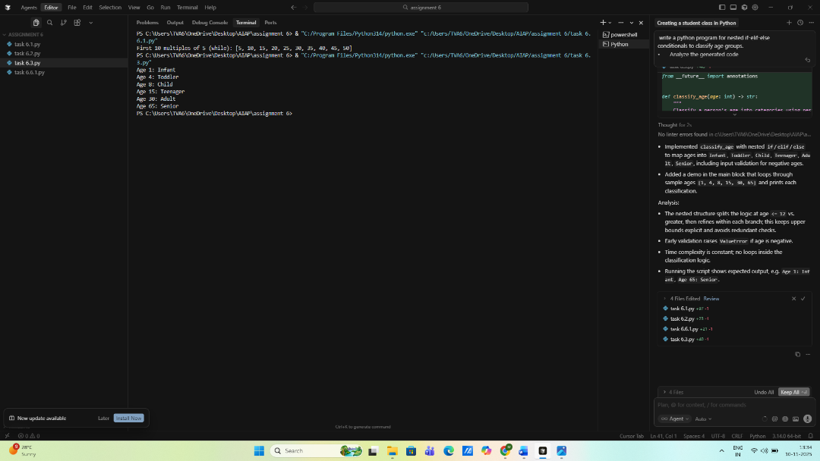  Output 2:  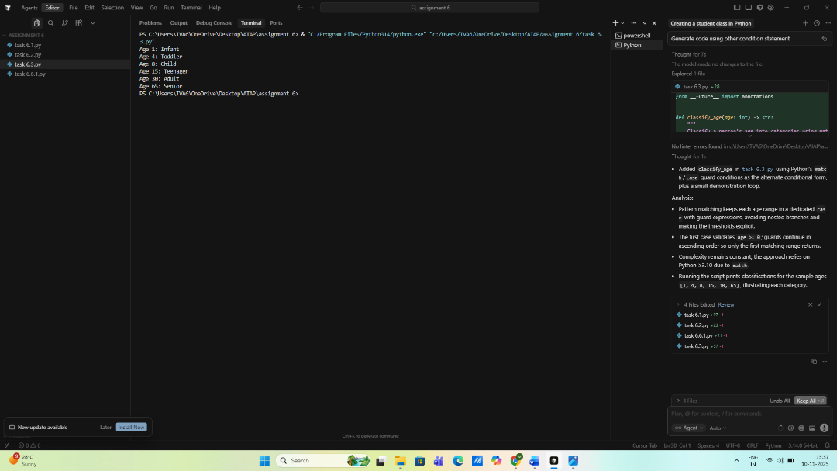  Task Description#4 (For and While loops)  - Generate a sum_to_n() function to calculate sum of first n numbers  - Analyze the generated code  - Get suggestions from AI with other controlled looping  Prompt: Write python function to calculate the sum of first 10 terms using for and while loop.  Code:  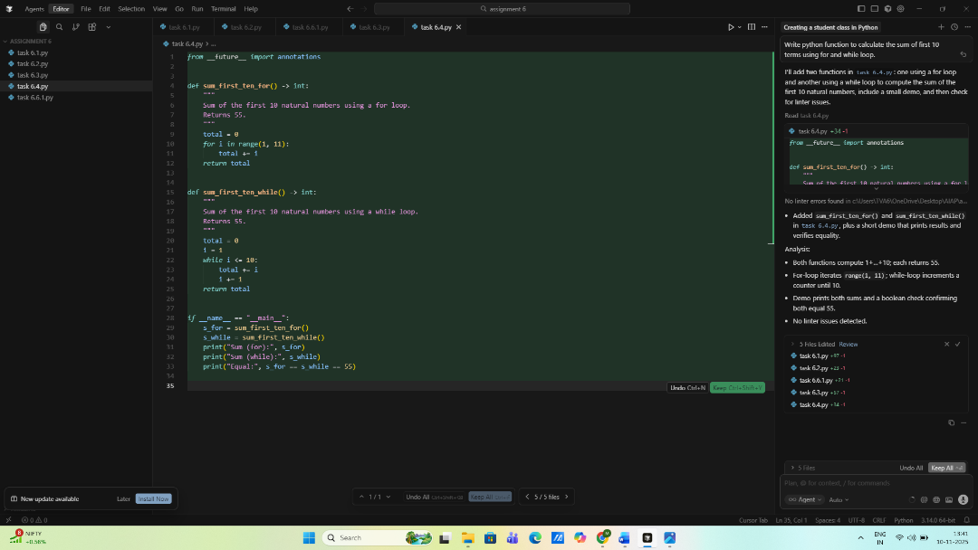  Analysis:  - Both functions compute 1+…+10; each returns 55.  - For-loop iterates range(1, 11); while-loop increments a counter until 10.  - Demo prints both sums and a boolean check confirming both equal 55.  - No linter issues detected.  Expected Output#4  - Python code with explanation  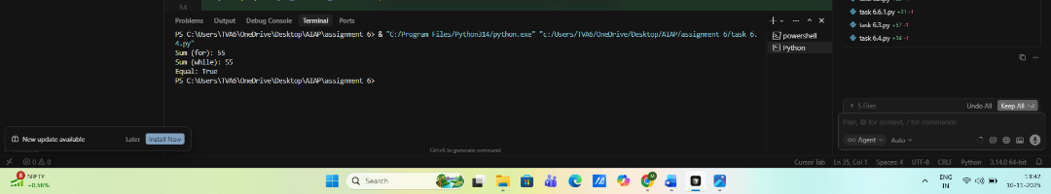  Task Description#5 (Class)  - Use AI to build a BankAccount class with deposit, withdraw, and balance methods.  - Analyze the generated code  - Add comments and explain code  Prompt: Write the python program to build a bank account class with deposit, withdrawal and balance method and analyze the code and add comments and explain the code.  Code:  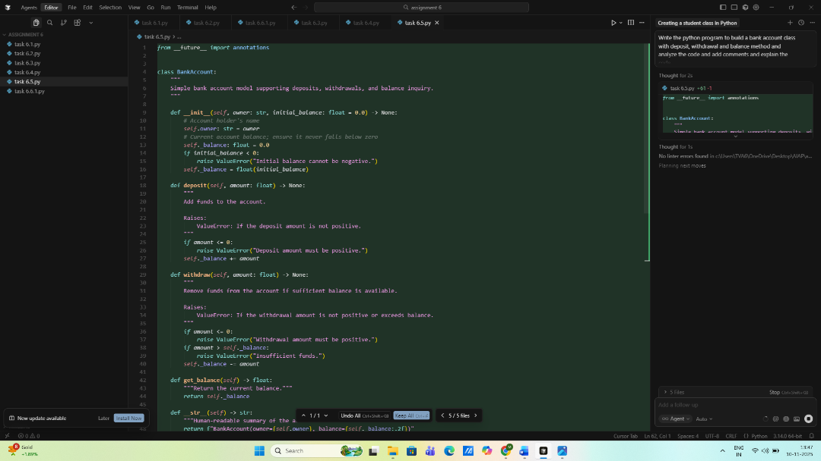  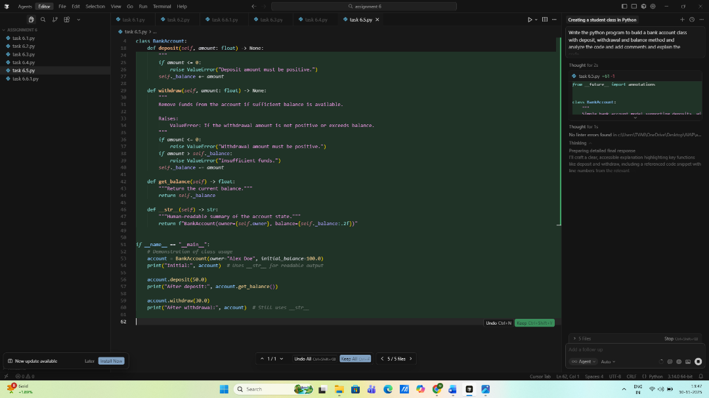  Explainnation:  - BankAccount encapsulates account state and operations so clients can interact through clear, validated methods, preventing direct balance manipulation.  - Constructor (__init__)  - Stores owner and initializes _balance.  - Rejects negative initial balances to keep state valid.  - deposit  - Requires a positive amount; otherwise raises ValueError.  - Adds funds to _balance.  - withdraw  - Ensures amount is positive and ≤ current balance.  - Raises ValueError if either condition fails, preventing overdrafts.  - Subtracts from _balance on success.  - get_balance  - Returns the current balance; accessor that preserves encapsulation.  - __str__  - Provides a friendly string like BankAccount(owner=Alex Doe, balance=120.00) for printing/logging.  - Demo block (if __name__ == "__main__":)  - Creates an account with Alex Doe and 100.0 starting balance.  - Prints initial state.  - Deposits 50.0, prints updated balance via get_balance().  - Withdraws 30.0, prints final state (using __str__).  - Inline comments and docstrings describe purpose of fields and methods; type hints clarify expected values.  Overall: straightforward class modeling core banking actions with defensive checks, easy to extend with features like transaction history or interest accumulation.  Expected Output#5  - Python code with explanation  Output:  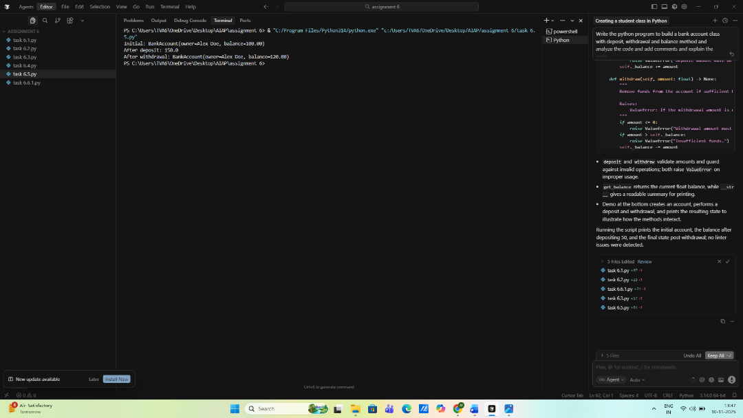  Note: Report should be submitted a word document for all tasks in a single document with prompts, comments & code explanation, and output and if required, screenshots  Evaluation Criteria: |  |  |  |  |  | Week3 - Wednesday
  Criteria | Max Marks
  Class | 1.0
  Loops | 1.0
  Conditional Statements | 0.5
  Total | 2.5 Marks

